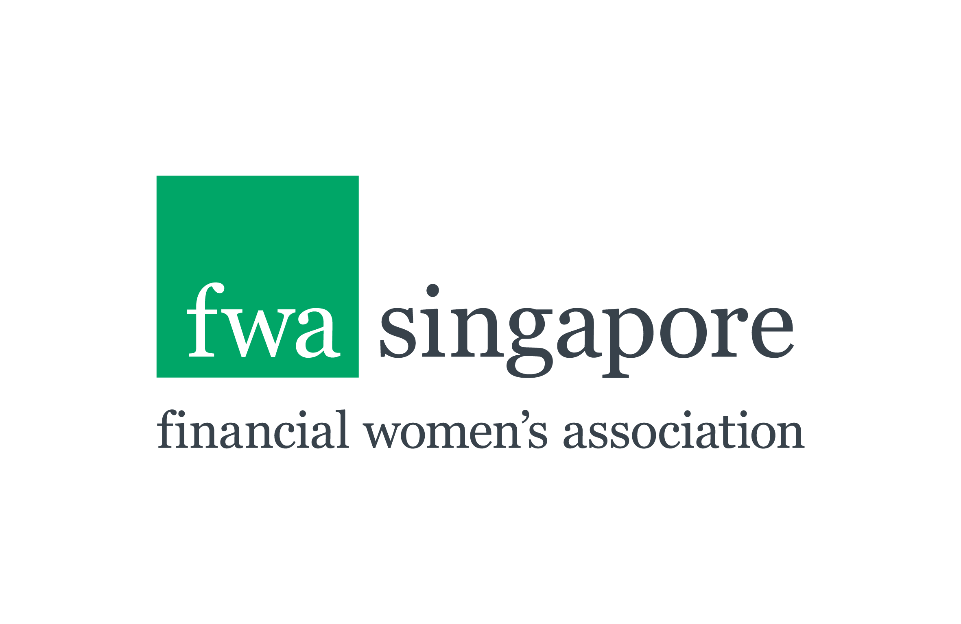

Mentor Application Form
FWA Advancing Women in Finance (AWF) 2017
April – November 2017

Application Process

Thank your for your interest in the FWA AWF 2017 Mentoring Programme and for applying to be a Mentor. Please read through this Application Form carefully and complete all PARTS from A to E.

Please take the time to provide accurate and thoughtful responses to the questions outlined below. The questionnaire has been designed to provide FWA with information to assist us in determining your suitability for this programme and for initially matching you with a number of Mentees.

This Form should be completed and submitted together with your CV. Hand written and incomplete applications will not be accepted.

All applications to include (and be submitted together):
- A fully completed Application Form
- A 1-2 page (max) copy of your CV

Email all of the above to: fwa.awf.sg@gmail.com

DEADLINE
Close of business on Tuesday 25 April 2017.

Please note that you are not able to make changes to the application once you have submitted it and late applications will not be considered.

Your Commitment as a Mentor
FWA is seeking fully committed Mentors who meet all of the criteria outlined below. Please ensure you check each of the boxes to acknowledge that you meet the minimum criteria and commitments.

PART A: Requirements of a Mentor

Mentoring roles are open to both male and female senior executives who meet the following criteria:

* | Approximately 10 or more years in a senior leadership role in the finance industry.
* | A desire to guide and motivate the next generation of women to achieve their career goals and aspirations i.e. to ‘pay it forward’.
* | Based in Singapore for the duration of the programme, ending November 2017.
* | Able to attend the ‘Speed Networking’ on 24 May 2017 and Kick-off on 20 June 2017 (schedules permitting).
* | Provide to the Mentee, 6 x one-hour mentoring sessions from June to November 2017.
* | In addition:
 | - Committed to consistent participation and attend 60% of the sessions, in particular the ‘speed networking’, Official Launch and mentor skills workshop.
 | - Have the business / industry knowledge and experience necessary to be able to discuss a wide range of topics and situations.
 | - Possess excellent listening and questioning skills.
 | - Will maintain confidentiality and integrity.
 | - Have an inquiring mind and open to new / different ways of thinking and doing.
 | - Complete an evaluation form at the end of the programme.

* By clicking on each of the boxes above you agree to the requirements and commitment being asked of you
as a Mentor on the 2017 Programme.

PART B: About You

- Why join AWF 2017 as a Mentor? What would you like to achieve?*
- Have you played the role of mentor in the past i.e. formal, informal, internal, external programme? Briefly (100 words max) outline the length of the programme and share one or two reflections of your experience(s).*
- How would you describe your mentoring style?*
- From your experience, what do you think are the keys to having a successful mentoring relationship?*
- Briefly describe the key responsibilities in your current role.*
- Describe your top three strengths.*
- Identify your top 3 challenges or potential ‘blind spots’ as a leader.*

* Please answer all

PART C: Shared Information
Should you be accepted as a Mentor, some information about you will be shared with other participants on the programme. Please complete the following, keeping in mind that it will not be shared publicly, or with anyone outside of the FWA Programme. (See PDP at end of this document).

- Name*
- Preferred name* (for badge)
- Job Title or last position held*
- Age ** (for matching only)
- Main email address*
- Alternate email address**
- NRIC or Passport Number**
- Telephone Number**
- Company Name*
- Industry*
- Function*
- Nationality*
- Years of work experience*
- Years living in Singapore*
- Countries you’ve lived in*
- What achievements are you most proud of? Include personal and business*
- Status (spouse/partner, children, pets etc)*
- What interests and hobbies do you have outside of the workplace?*
- What’s the riskiest thing you’ve ever done?*
- Other information you would like to share about yourself?

* Please answer all
** Will not be shared internally with other participants

PART D: Working with a Mentee – Your Preferences

- What areas of expertise do you bring to mentoring? (Please click the boxes which apply).

Managing work / life balance / family
Building confidence and enhancing self-esteem
Developing leadership skills i.e. influencing, public speaking, communications etc
Expanding professional network
Career development and leadership focus
Industry expertise – please specify
Other – please specify
- 2. What additional information about you, in regards to matching you with a Mentee, would be
- useful for us to know?

PART E: Personal Data Protection (PDP) Policy
Please read and tick the box below to agree to the following disclaimer:

The personal data collected in this form will only be used by FWA and Differentiate Pte Ltd for the purposes set out below:
- processing your application for admission to FWA’s AWF 2017 (‘the Programme”).
- any matters or activities relating to or in connection with the Programme, including selected marketing of the Programme within FWA either before, during or after the Programme.
- any purpose relating to or in connection with compliance with any law or regulation.
You also agree that FWA may use images, quotations, photos and videos which feature you and which are generated before, during or after the Programme to publicise the Programme within FWA. Your personal information may be shared with members of the FWA Executive Committee, the FWA mentoring team and Differentiate Pte Ltd for assessment, learning and development related purposes.
Please note that it is mandatory for you to provide the personal data (marked with asterisks) in this form. In the event that you do not provide such personal data, we may not be able to process your application.
In submitting your application, you agree that the information given in this application is, to the best of your knowledge, accurate and complete. You understand that the provision of any false or misleading information will lead to disqualification of your application.
Your right of access includes the right to obtain a copy of the personal data you provided, and to the correction of any personal data held. Any request for access to and/or correction of personal data should be addressed to fwa.awf.sg@gmail.com.

Prior to submitting this form, please click on the box below:

I have read and understand the above Personal Data Protection Policy and have completed PARTS A to E of this Application Form

Date:

Save this document and submit to fwa.awf.sg@gmail.com together with a 1-2 page CV prior to the deadline of close of business on Tuesday 25 April 2017.

Protégé is 100% owned by Differentiate Pte Ltd (200612413N)
10 Anson Road #12-14, International Plaza, Singapore 079903
M: +65 9363 3506
T: +65 6509 0768
E: contact@differentiatenow.com
W: www.protege.asia
FB: https://www.facebook.com/protege.asia

AWF2017_MentorApplicationForm_15.3.17.docx

